**Powerful Trading Strategy**

**Using MA Crossover**

**POWER OF MA Crossover**

**by RAJ KUMAR**

**Page No** **-1**

**In this book you know powerful trading strategy using moving average crossover and how to use crossover with other indicator ( MACD , RSI , SUPPORT LEVEL, RESISTANCE LEVEL, PIVOT POINT AND FIBONACCI)**

**Also include formula for given indicator and how to use given indicator in trading for profit.**

**I try to give best strategy in this book and I am using all strategy for trading.**

**I request to all reader and trader that before using my strategy on live market. Please test on paper trading or demo account.**

**Page No** **-2**

**I am not responsible for any profit or loss in trading using given strategy.**



**Thanks for reading this book**

**Author : Raj Kumar**

**Date : 15 Aug 2021**

**Page No** **-3**

**About Author**

**I was started trading in 2016 in forex market on Alpari. I study many indicators for best result but I found satisfaction on moving average . I tried moving average with other indicator . After 5 years I am satisfied with my study and profit from trading. Now I use this strategy in cryptocurrency trading ( Hitbtc and Binance ) , stock market ( Angel Broking ) and forex ( Alpari and Icmarket).**

**Page No** **-4**



**Author : Raj Kumar Mantrik**

**Address : J 34/209,West Sagar pur, New Delhi110046.India**

**Email :** [**aksharmty@ymail.com**](mailto:aksharmty@ymail.com)

**Phone No. +91-9213816442**

**Page No** **-5**

**WHAT is Trading**

**Trading is simple word : Buy on low and sell on high or sell on high and buy on low .**

**Requirement for trading**

**Just a PC or Smartphone and few money for buy or sell**

**What is difference between in stock , crypto and forex**

**No big difference just trading time differ but trading principle are same.**

**What is Take Profit**

**Difference between buy price and sell price.**

**Example : If you buy a stock on $100**

**Page No** **-6**

**and you want sell this on $120. Then your take profit are 120 and your profit $20 after sell.**

**What is Stop-loss**

**Stop-loss is your loss capacity in one trade.**

**Example : After study chart you feel now market go up and you buy a stock but some news your stock not go up then you forget few fund and protect big fund to loss.**

**What is Trailing Stop-loss**

**After buying stock on $100 and you think price go up $105 but see on chart price ready to go more up then you wait for**

**Page No** **-7**

**exit. After waiting price go on $120 then come back down and you sell on more then $115. This profit are more then your expected profit, its call trailing stop-loss .**

**\*\*\*\*\***

# **Popular Active Trading Methods**

**Active trading is the act of buying and selling securities based on short-term movements to profit from the price movements on a short-term stock chart. The mentality associated with an active trading strategy differs from the long-term, buy-and-hold strategy found among**

**Page No** **-8**

**passive or indexed investors. Active**

**traders believe that short-term movements and capturing the market trend are where the profits are made.**

**\*\*\*\*\***

**There are various methods used to accomplish an active trading strategy, each with appropriate market environments and risks inherent in the strategy. Here are four of the most popular active trading strategies and the built-in costs of each strategy.**

**Page No** **-9**

**Day trading, position trading, swing trading, and scalping are four popular active trading methodologies.**

## **1. Day Trading**

**Day trading is perhaps the most well-known active trading style. It's often considered a pseudonym for active trading itself. Day trading, as its name implies, is the method of buying and selling securities within the same day. Positions are closed**

**Page No** **-10**

**out within the same day they are taken, and no position is held overnight. Traditionally, day trading is done by professional traders, such as specialists or market makers. However, electronic trading has opened up this practice to novice traders.**

**\*\*\*\*\***

## **Position Trading**

**Some actually consider position trading to be a buy-and-hold strategy and not active trading. However, position trading, when done by an advanced trader, can be a**

**Page No** **-11**

**form of active trading.**

**Position trading uses longer term charts – anywhere from daily to monthly – in combination with other methods to determine the trend of the current market direction. This type of trade may last for several days to several weeks and sometimes longer, depending on the trend.**

**Trend traders look for successive higher highs or lower highs to determine the trend of a security. By jumping on and riding the "wave," trend traders aim to benefit from**

**Page No** **-12**

**both the up and downside of market movements. Trend traders look to determine the direction of the market, but they do not try to forecast any price levels. Typically, trend traders jump on the trend after it has established itself, and when the trend breaks, they usually exit the position. This means that in periods of high market volatility, trend trading is more difficult and its positions are generally reduced.**

**\*\*\*\*\***

## **Swing Trading**

**When a trend breaks, swing traders typically get in the game. At the end Page No** **-13**

**of a trend, there is usually some price volatility as the new trend tries to establish itself. Swing traders buy or sell as that price volatility sets in. Swing trades are usually held for more than a day but for a shorter time than trend trades. Swing traders often create a set of trading rules based on technical or fundamental analysis.**

**These trading rules or algorithms are designed to identify when to buy and sell a security. While a swing-trading algorithm does not have to be exact and predict the peak or**

**Page No** **-14**

**valley of a price move, it does need a**

**market that moves in one direction**

**or another. A range-bound or sideways market is a risk for swing traders.**

## **4. Scalping**

**Scalping is one of the quickest strategies employed by active traders. Essentially, it entails identifying and exploiting bid-ask spreads that are a little wider or narrower than normal due to temporary imbalances in supply and demand.**

**Page No** **-15**

**A scalper does not attempt to exploit**

**large moves or transact high volumes. Rather, they seek to capitalize on small moves that occur frequently, with measured transaction volumes. Since the level of profit per trade is small, scalpers look for relatively liquid markets to increase the frequency of their trades. Unlike swing traders, scalpers prefer quiet markets that aren't prone to sudden price movements.**

**Page No** **-16**

## What is Candlestick Chart?

A candlestick chart represents the price movement of a stock over a certain time period. This type of chart is quite popular among traders because they are easy to read and understand.

## Components of a Candlestick

A candlestick offers a wide range of information in a simple manner. Each candlestick is composed of a body and wicks (thin lines extending above and below the body).

**Page No** **-17**

A typical candlestick looks like this: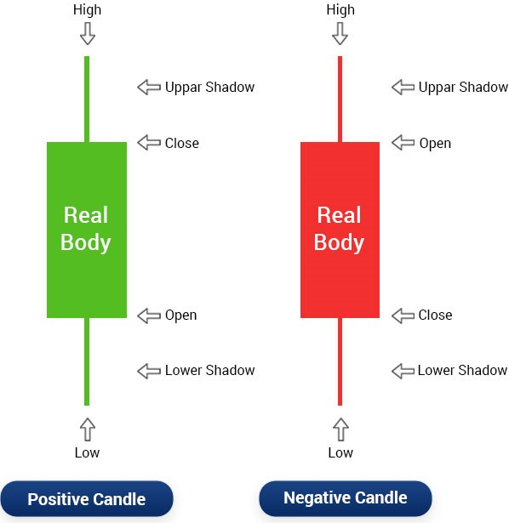

**Page No.18**

* A white (or green) candlestick is formed if the close is above the open
* A black (or red) candlestick is formed if the close is below the open
* The space between the open and close points is depicted as the ‘real body’
* The thin lines that extend from the top and the bottom are known as wicks or shadows
* The top of the upper wick represents the ‘high’

**Page No** **-19**

* The bottom of the lower wick represents the ‘low'

Fun fact: The candlestick chart that is so commonly used today dates back to the 16th century! That’s why it is also known as Japanese candlesticks.

## How to read Candlestick Chart?

A candlestick chart includes the open, close, high and low price of a stock over a specific time frame. This time frame can be fixed by the trader as per his requirement.

For example, if the time limit is fixed at ten minutes, then a new candlestick is created in the graph

**Page No** **-20**

after every ten minutes.

Then, by simply looking at the chart, the trader can find out all the four major [price movements of the stock](https://www.edelweiss.in/investology/fundamental-analysis-218cf3/how-stock-prices-change-52166b) over a particular time frame.

## Types of Patterns in a Candlestick Chart

Candlestick chart patterns give you an idea about prevailing investors’ sentiment and understand the relationship between demand and supply, greed and fear, etc. There are broadly two types of candlestick patterns – bullish and bearish. Let’s learn more about them.

**Page No** **-21**

In the bullish pattern, there are several recognisable patterns. They are:

### Hammer Pattern

In the hammer candlestick chart pattern, you will see a candle with a short body and long lower wick. The hammer pattern indicates that while there has been a **Page No.12**

selling pressure, prices have been pushed up by a strong surge. If you find more green candles than red, then it indicates a stronger bull market.

**Page No** **-22**

### Inverse Hammer Pattern

In this candlestick chart pattern, you will find candles with a short body and a long upper wick. The Inverse Hammer pattern indicates that there is a buying pattern followed by a selling pattern.

### Bullish Engulfing Pattern

The Bullish Engulfing candle chart pattern is an indication of a bullish market pushing up prices in spite of opening lower than the previous day. In this type of candlestick graph, the first candle is short red that’s engulfed by a large green candle.

**Page No** **-23**

Piercing Line Pattern

It’s a type of candlestick chart where there’s a long red candle followed by a long green one. It must be noted that here, the closing price of the green candle is more than halfway up the body of the first red candle, indicating a strong buying pressure.

### Three White Soldiers Pattern

This candlestick chart pattern is generally observed after a downturn or during price consolidation. Here, there are three green candles that open and close high than the previous day and indicates a strong bull trend.

**Page No** **-24**

Just like bullish patterns, bearish patterns too have many under its belt. They are:

### Hanging Man Pattern

In this type of candlestick chart, the candle has a short body and long lower wick. It’s an indication that selling pressure was more than buying and that bears are slowly gaining control.

### Shooting Star Pattern

In this candle chart, the candle has a short body and long upper wick. It’s an indication that selling pressure is taking control of the market.

**Page No** **-25**

### Bearish Engulfing Pattern

In this candlestick chart pattern, the first candle is a short green one that’s engulfed by a large green one. It’s an indication of the market slowdown.

### Evening Star Pattern

This candlestick trading chart is one where there’s one candle with a short body which is in between one long red and one long green candle. The short and long candles don’t overlap and it indicates a reversal of an upward trend.

**Page No** **-26**

### Three Blacks Crows Pattern

This candle chart pattern consists of three consecutive red candles with short wicks, and they open and close lower than the earlier day. This candlestick chart signals a strong upcoming bear market.

**Page No-27**

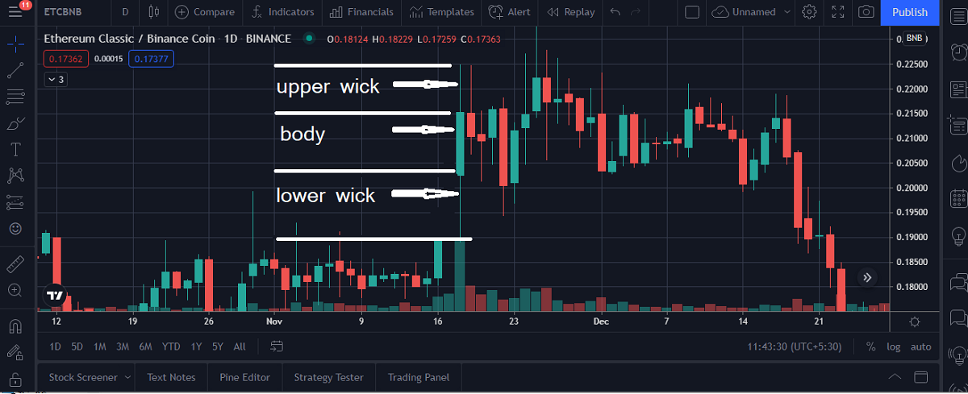

**Page No-28**

### **Technical Analysis Work Shop**

### 

**Page No** **-29**

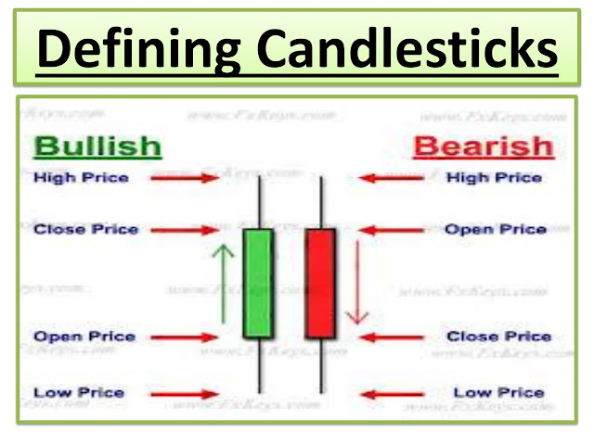

**Page No** **-30**

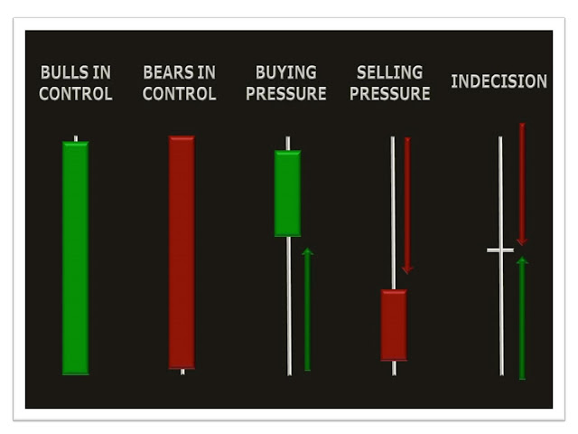

**Page No** **-31**

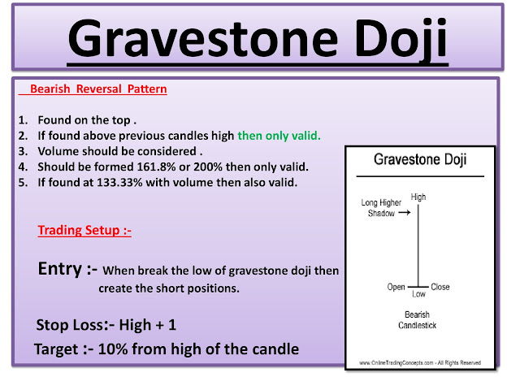

**Page No** **-32**

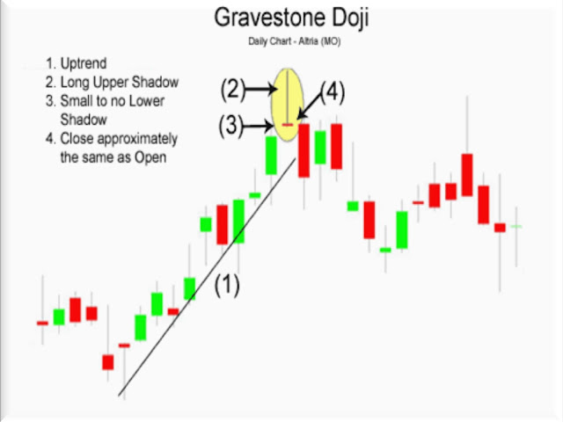

**Page No** **-33**

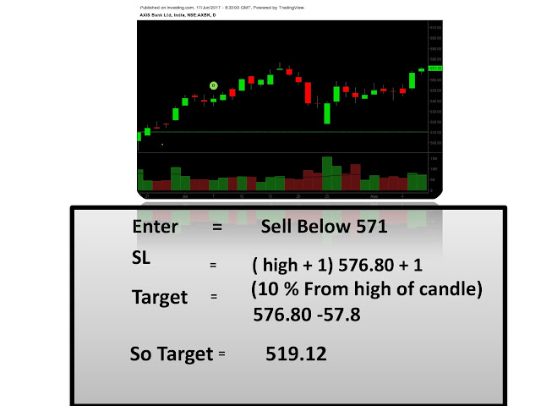

**Page No** **-34**

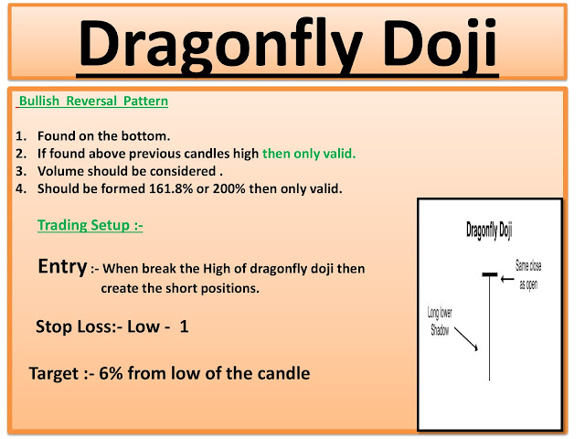

**Page No** **-35**

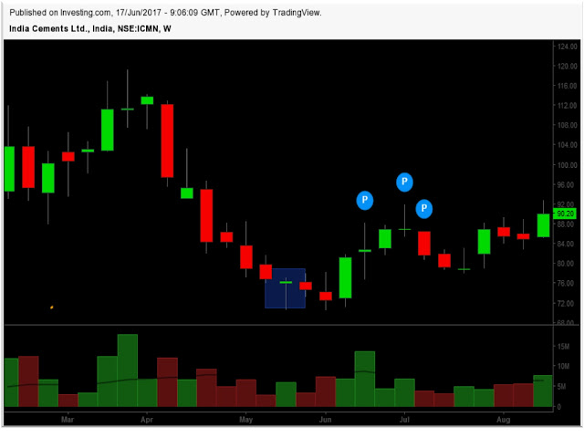

**Page No** **-36**

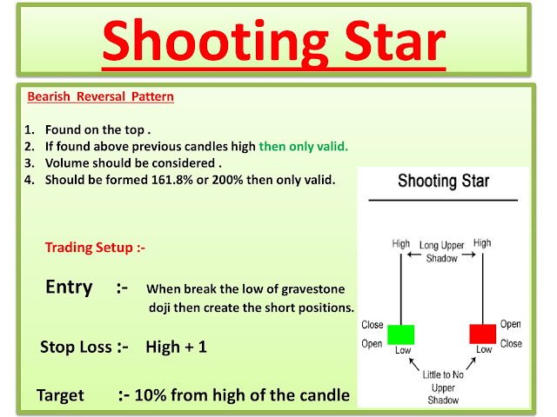

**Page No** **-37**

**Page 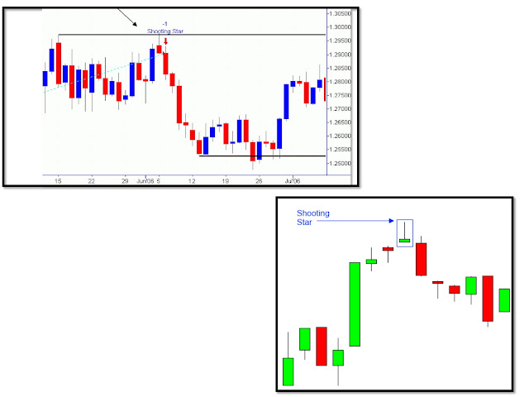No-38**

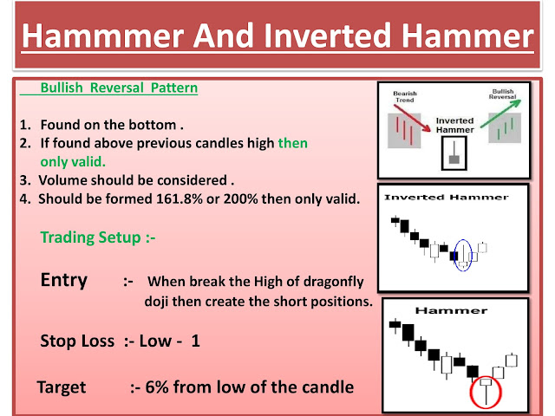

**Page No** **-39**

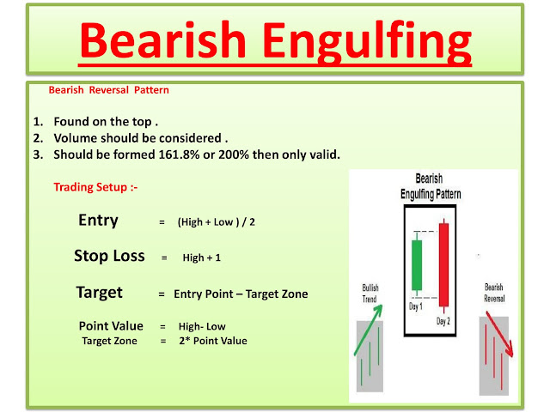

**Page No-40**

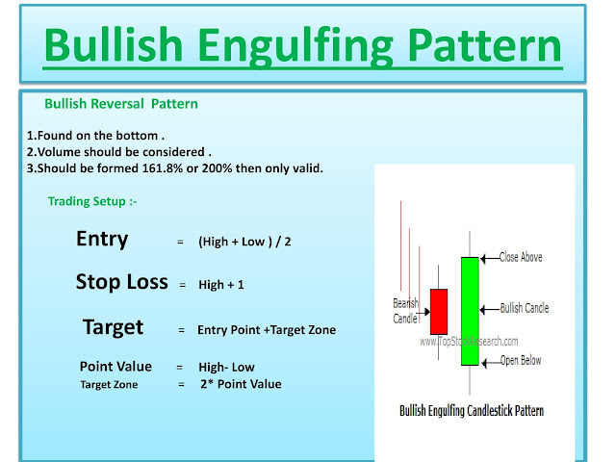**Page No** **-41**

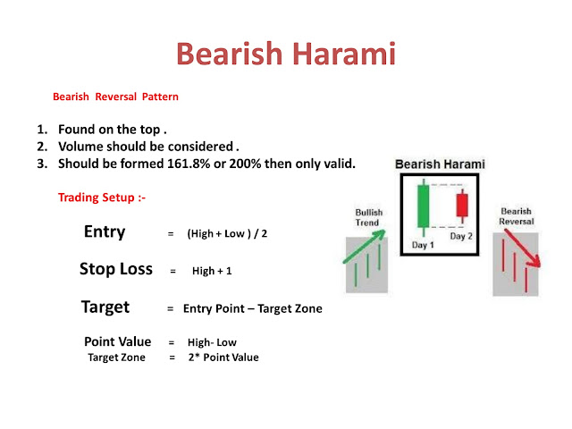

**Page No** **-42**

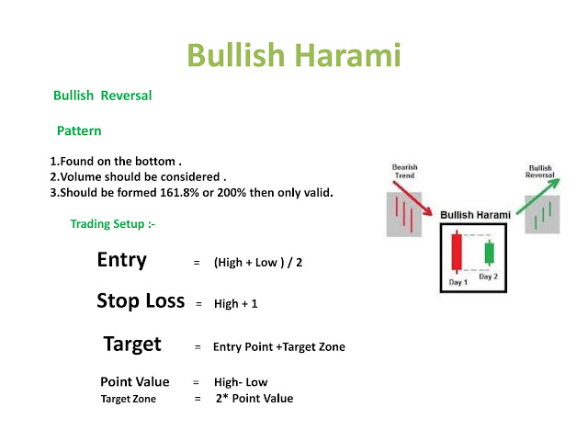

**Page No** **-43**

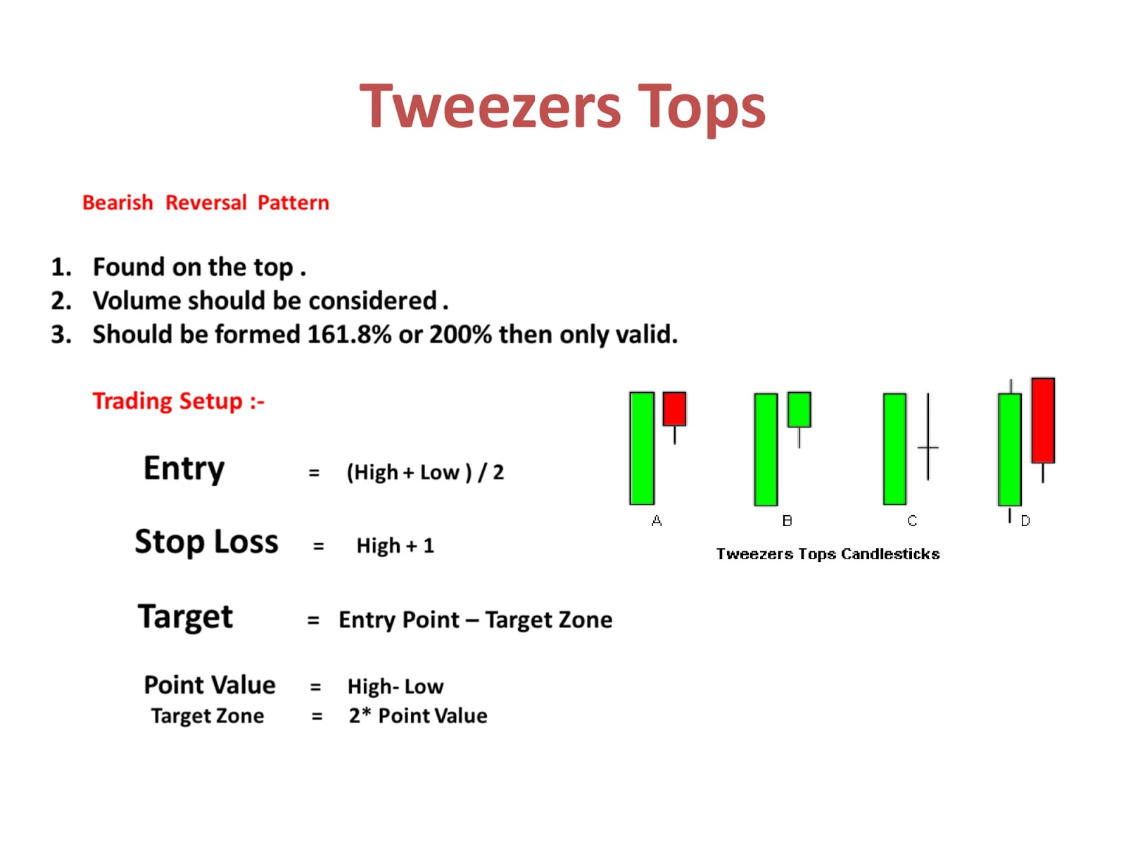

**Page No** **-44**

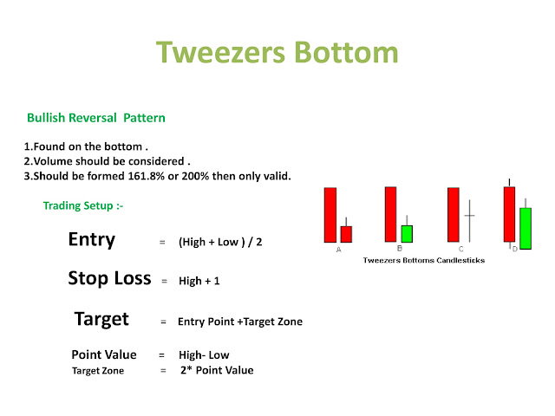**Page No-**45

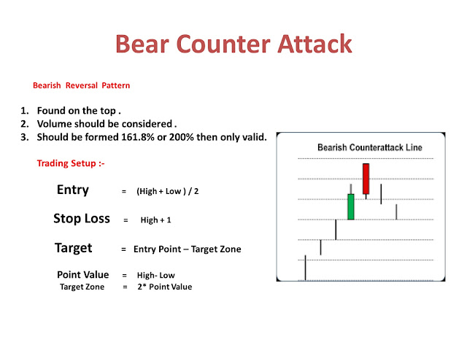

**Page No** **-46**

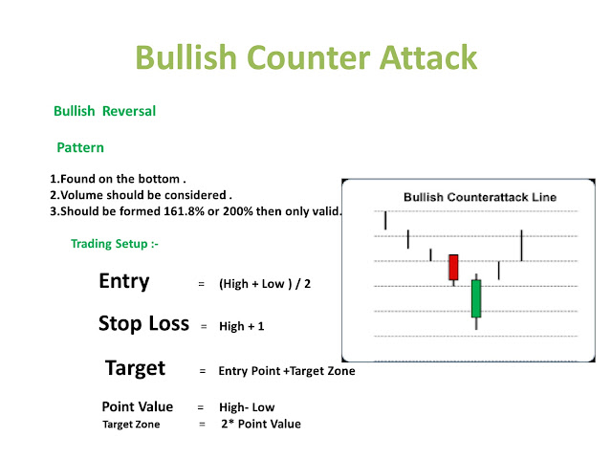

**Page No** **-47**

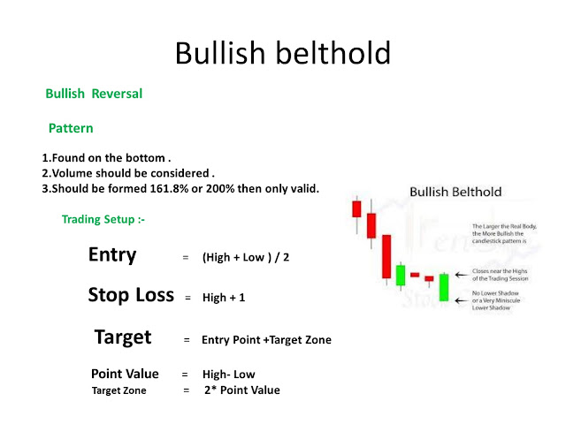

**Page No** **-48**

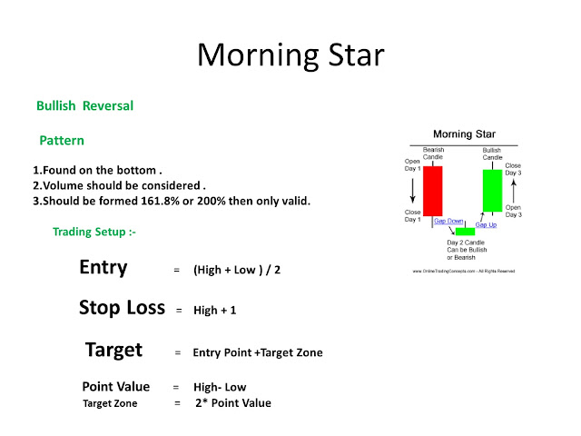

**Page No** **-49**

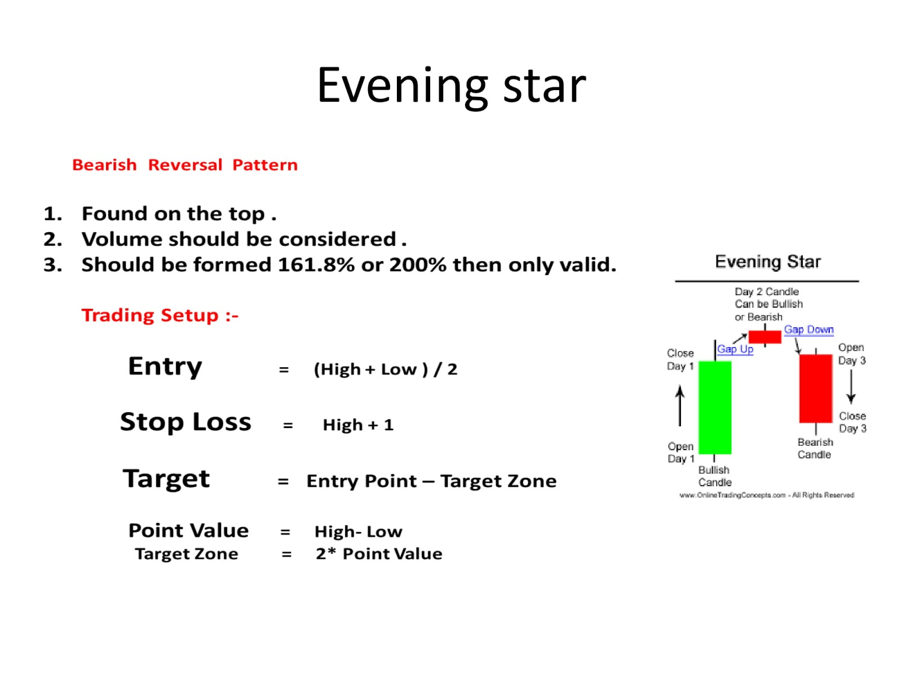

**Page No** **-50**

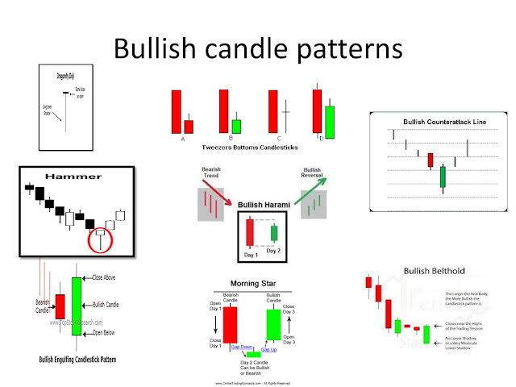

**Page No** **-51**

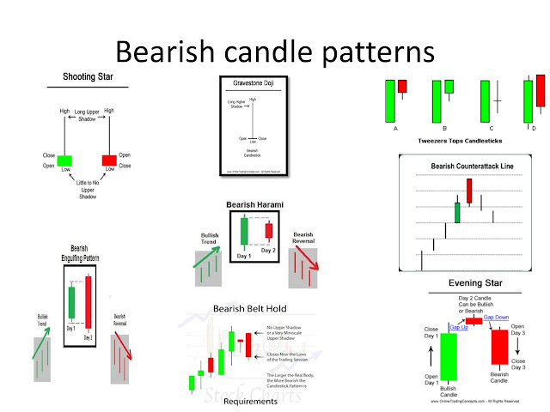

**Page No** **-52**

## Simple Moving Average

**A simple moving average is formed by computing the average price of a security over a specific number of periods. Most moving averages are based on closing prices; for example, a 5-day simple moving average is the five-day sum of closing prices**

**Page No** **-53**

**divided by five. As its name implies, a moving average is an average that moves. Old data is dropped as new data becomes available, causing the average to move along the time scale. The example below shows a 5-day moving average evolving over three**

**Page No** **-54**

**days. Daily Closing Prices: 11,12,13,14,15,16,17**

**First day of 5-day SMA: (11 + 12 + 13 + 14 + 15) / 5 = 13**

**Second day of 5-day SMA: (12 + 13 + 14 + 15 + 16) / 5 = 14**

**Page No** **-55**

**Third day of 5-day SMA: (13 + 14 + 15 + 16 + 17) / 5 = 15**

**The first day of the moving average simply covers the last five days. The second day of the moving average drops the first data point (11) and adds the new data point (16). The third day Page No** **-56**

**of the moving average continues by dropping the first data point (12)and adding the new data point (17). In the example above, prices gradually increase from 11 to 17 over a total of seven days. Notice that the moving average also rises from 13 to 15 over a**

**Page No** **-57**

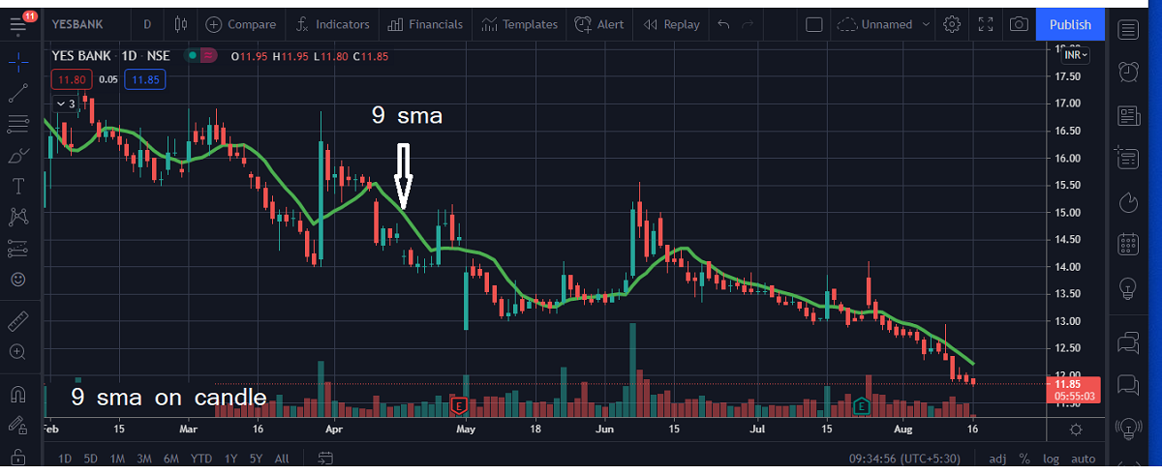**Page No** **-58**

**three-day calculation period.Also, notice that each moving average value is just below the last**

**price. For example, the moving average for day one equals 13 and the last price is 15. Prices the prior four days were lower and this causes the moving**

**Page No** **-59**

**average to lag.**

**Exponential Moving Average**

**Exponential moving averages (EMAs) reduce the lag by applying more weight to recent prices. The weighting applied to the most recent price depends on the number of periods in the moving average. EMAs**

**Page No** **-60**

**differ from simple moving averages in that a given day's EMA calculation depends on the EMA calculations for all the days prior to that day. You need far more than 10 days of data to calculate a reasonably accurate 10-day EMA.**

**Page No** **-61**

**There are three steps to calculating an exponential moving average (EMA). First, calculate the simple moving average for the initial EMA value. An exponential moving**

**average (EMA) has to start somewhere, so a simple moving average is used as**

**Page No-62**

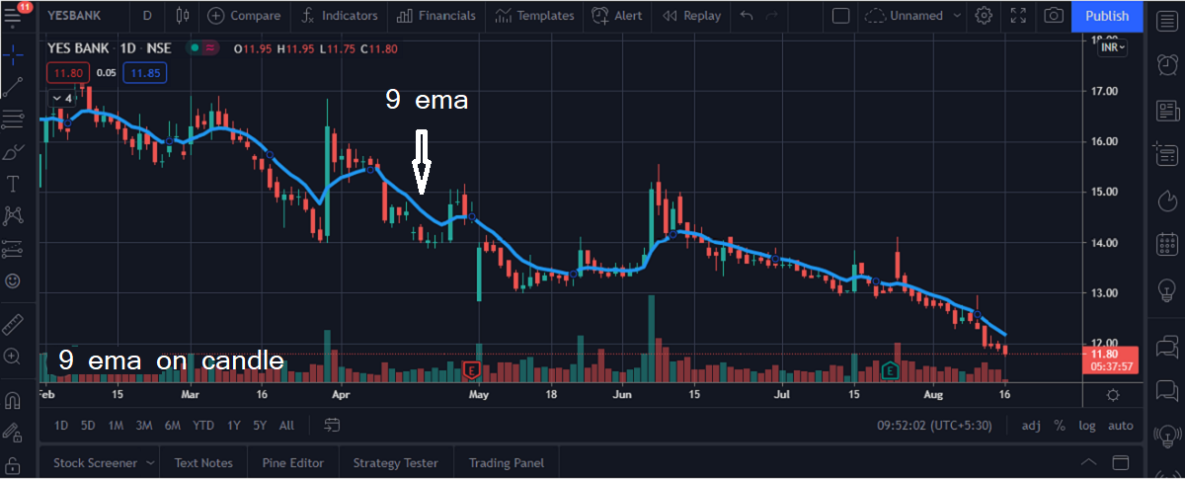

**the previous period's EMA in the first calculation. Second, calculate the weighting multiplier.**

**Third, calculate the exponential moving average for each day between the initial EMA value and today, using the price, the multiplier, and the**

**Page No-64**

**previous period's EMA value. The formula below is for a 10-day EMA**

**Initial SMA: 10-period sum/ 10**

**Multiplier: (2 / (Time periods + 1) ) = (2 / (10 + 1) ) = 0.1818 (18.18%)**

**EMA: {Close - EMA(previous day)} x multiplier + EMA(previous day)**

**Page No-65**

## **Simple vs Exponential Moving Averages**

Even though there are clear differences between simple moving averages and exponential moving averages, one is not necessarily better than the other. Exponential moving averages have less lag and are therefore more sensitive to recent prices - and recent price changes. Exponential moving averages will turn before simple moving averages. Simple moving averages, on the

**Page No-66**

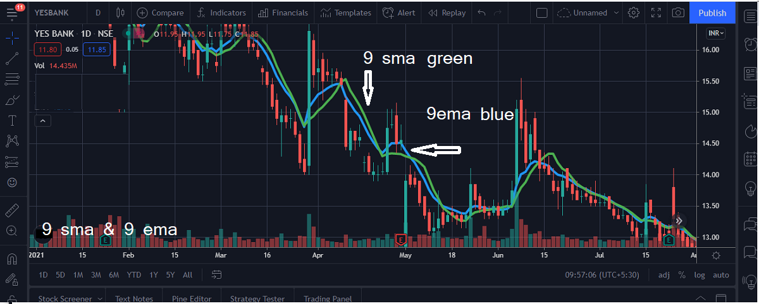

**Page No-68**

other hand, represent a true average of prices for the entire time period.

**Page No-69**

**How to Trade on Single Moving Average(MA)**

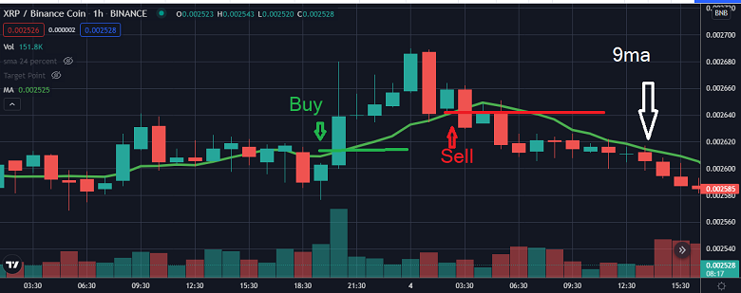

**How to Trade on Single Moving Average(MA)**

**For trading you can any length of moving average . Mostly people use 5 , 9, 20 ,50 ,100 ,200 moving average for trading. but I use my favourite 9ma for example .**

**Long Entry : If current price above of 9 ma and price given breakout of last candle high then you can place a buy order ( make a long position in the market).**

**Long Exit : Price above the 9 ma and price break last candle low then you can exit from long position.**

**Page No-71**

**Short Entry : If current price below of 9 ma and price given breakout of last candle low then you can place a sell order ( make a short position in the market).**

**Short Exit : Price below the 9 ma and price break last candle high then you can exit from short position.**

**Page No-72**

**Crossover**

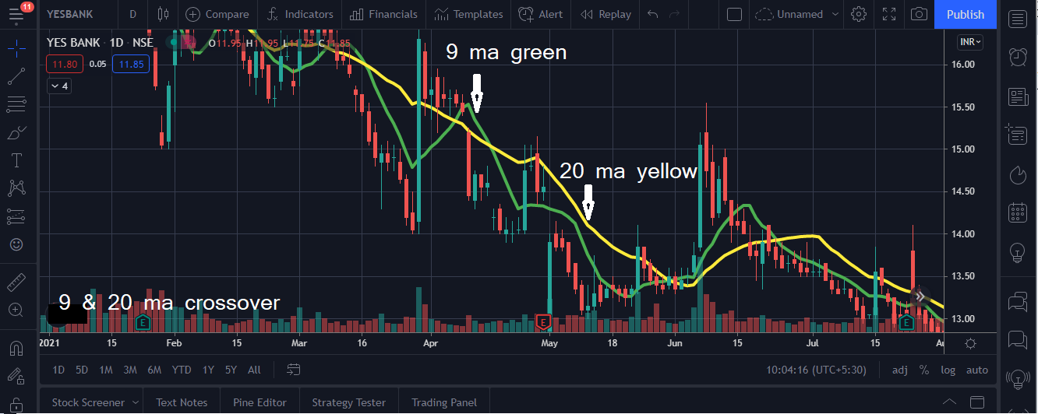**Page No-73**

**How to Trade on Crossover Moving Average**

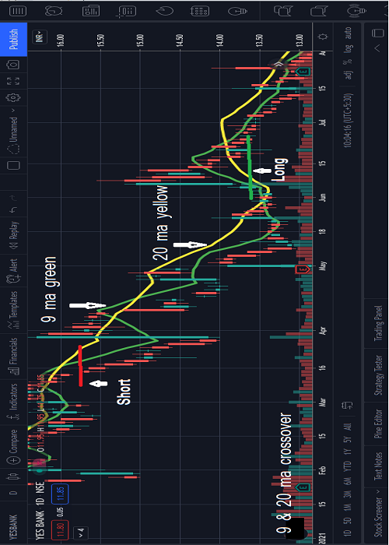

**How to Trade on Crossover Moving Average**

**For trading you can any length of moving average crossover. Mostly people use 5 and 10, 9 and 20, 20 and 50 ,50 and 100 ,100 and 200 moving average crossover for trading. but I use my favourite 9ma and 20ma for example .**

**Long Entry : 9 ma value cross above 20 ma value and current price above of 9 ma and price given breakout of last candle high then you can place a buy order ( make a long position in the market).**

**Long Exit : Price above the 9 ma and price break last candle low then you**

**Page No-75**

**can exit from long position.**

**Short Entry : 9 ma value cross below 20 ma value and current price below of 9 ma and price given breakout of last candle low then you can place a sell order ( make a short position in the market).**

**Short Exit : Price below the 9 ma and price break last candle high then you can exit from short position.**

**Page No-76**

**What is MACD**

**Developed in the late 1970s by Gerald Appel, the Moving Average Convergence Divergence oscillator is regarded as one of the most effective and straightforward momentum indicators. MACD is a trading indicator which is used for the technical analysis of stock prices. The indicator enables analysts to reveal directional changes, strength, momentum as well as the duration of**

**Page No-77**

**a trend in the price of a stock.**

## **How to calculate MACD?**

**To calculate Moving Average Convergence Divergence, you need to subtract the long term EMA from the short term EMA.**

**The following are the MACD calculation formulae and an explanation of the same.**

**Page No-78**

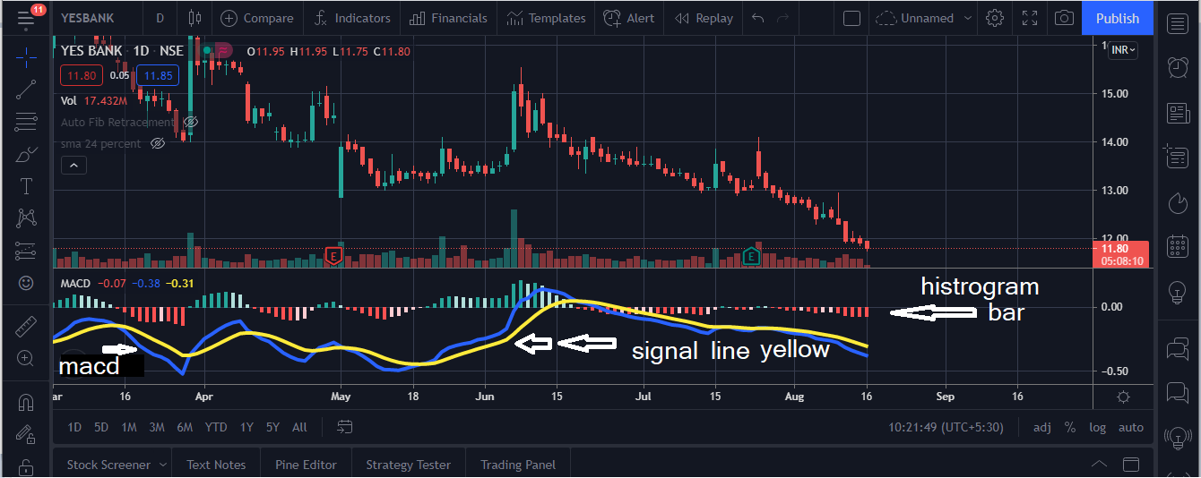**MACD**

**Page No-79**

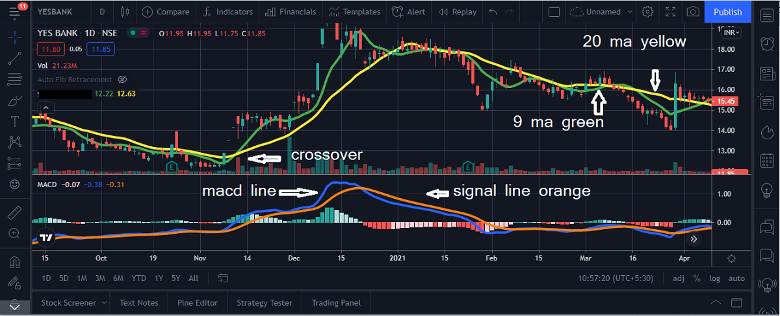

**Page No-80**

**1. MACD Line: (12-day EMA – 26-day EMA)**

**2. Signal Line: 9-day EMA of MACD Line**

**3. MACD Histogram: MACD Line – Signal Line**

**It typically takes 12 and 26 days exponential moving averages to construct MACD lines. MACD is thus calculated as the difference between the two EMAs values, i.e. (26 periods – 12 periods). A nine-day EMA is**

**Page No-81**

**known as the signal line, which is**

**then placed on top of the MACD line. It functions as a trigger to purchase and sale signals. As a trader, you can purchase securities when the MACD crosses above the signal line and sell them when it crosses below the signal line. You can interpret the Moving Average Convergence Divergence in various ways, although the most common methods include crossovers,** divergences as well as rapid rises or falls.

**Page No-82**

**How to Trade on MACD & Crossover MA**

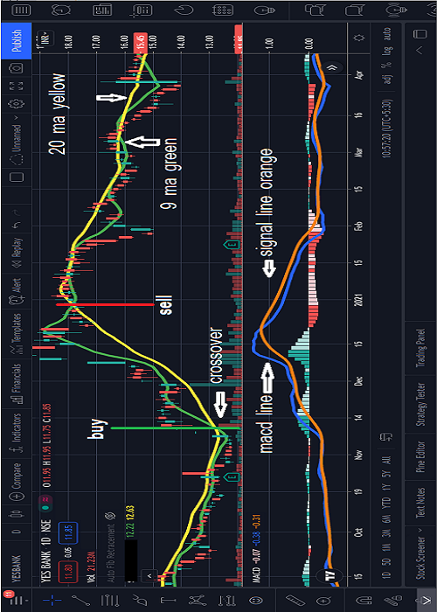

**Page No-83**

**How to Trade on MACD Crossover with 9 MA**

**Long Entry : macd above signal line and current price above of 9 ma and price given breakout of last candle high then you can place a buy order ( make a long position in the market).**

**Long Exit : macd below signal line and Price below the 9 ma then you can exit from long position.**

**Short Entry : macd below signal line and current price below of 9 ma and price given breakout of last candle low then you can place a sell order ( make a short position in the market).**

**Page No-83**

**Short Exit : macd above signal line and price above 9 ma then you can exit from short position.**

**Page No-84**

# **Relative Strength Index (RSI)**

**The Relative Strength Index (RSI), developed by J. Welles Wilder, is a momentum oscillator that measures the speed and change of price movements. The RSI oscillates between zero and 100. Traditionally the RSI is considered overbought when above 70 and oversold when below 30. Signals can be generated by looking for divergences and failure swings. RSI can also be used to identify the general trend.**

**Page No-85**

### **Calculation**

**The RSI is a fairly simple formula, but is difficult to explain without pages of examples. Refer to Wilder's book for additional calculation information. The basic formula is:**

**RSI = 100 – [100 / ( 1 + (Average of Upward Price Change / Average of Downward Price Change ) ) ]**

**Page No-86**

**RSI**

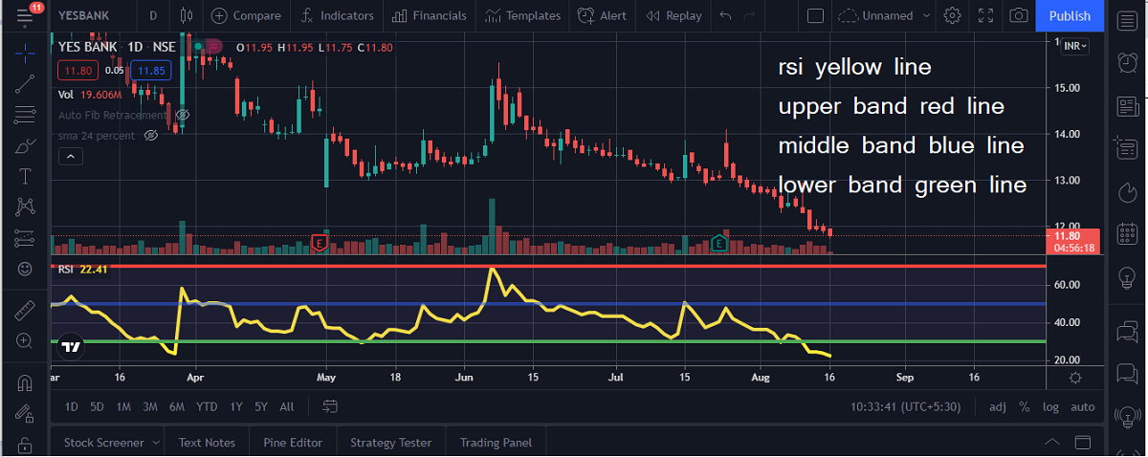

**Page No-87**

**How to Trade on RSI with Crossover MA**

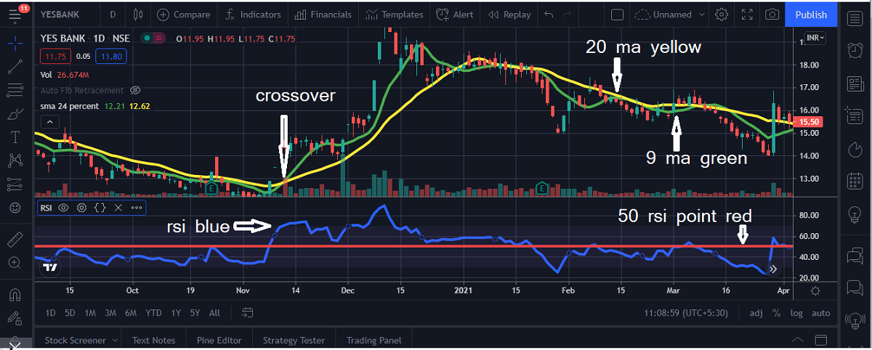

**Page No-88**

**How to Trade on RSI with Crossover MA**

**Long Entry : RSI value greater then 50 and 9 ma value cross above 20 ma value and current price above of 9 ma and price given breakout of last candle high then you can place a buy order ( make a long position in the market).**

**Long Exit : 9 ma below 20 ma then you can exit from long position.**

**Short Entry : RSI value less then 50 and 9 ma value cross below 20 ma value and current price below of 9 ma and price given breakout of last candle low then you can place a sell order ( make a short position in the market).**

**Page No-89**

**Short Exit : 9 ma above 20 ma then you can exit from long position.**

**Page No-90**

**Support AND Resistance Level**

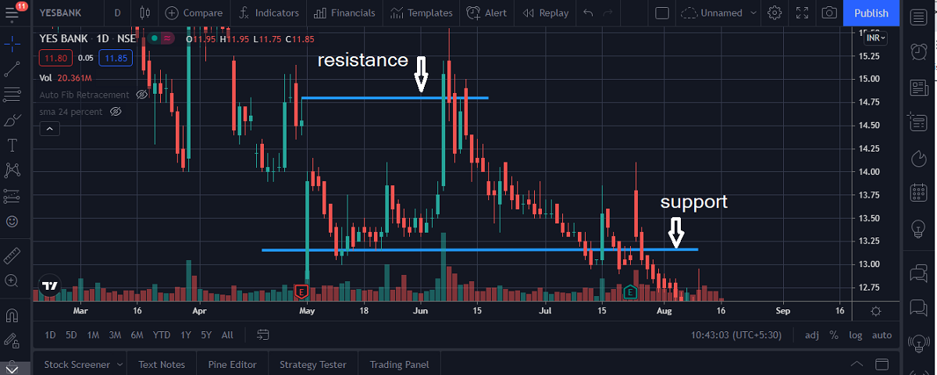

**Page No-91**

**Support AND Resistance with crossover MA**

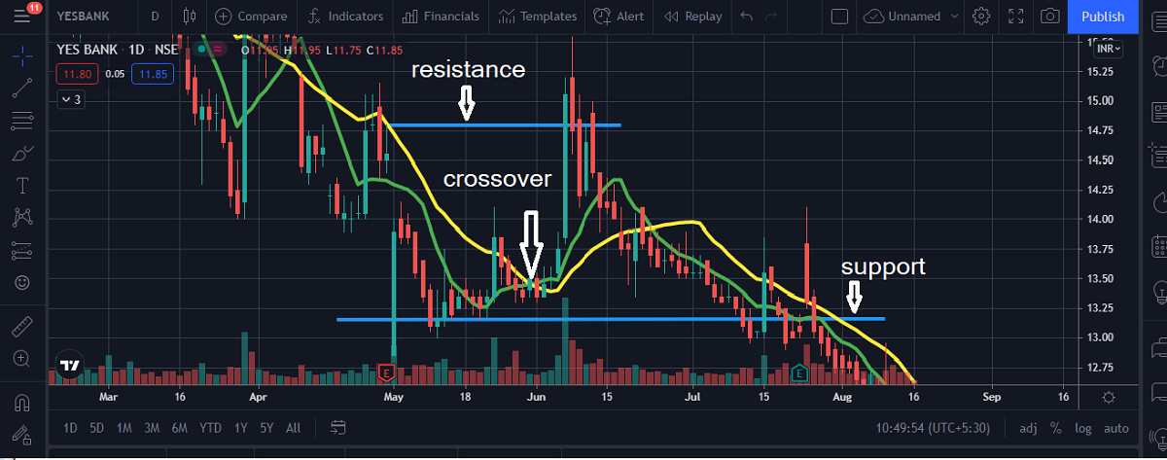

**Page No-92**

**Support AND Resistance**

**Resistance is something which stops the price from rising further. The resistance level is a price point on the chart where traders expect maximum supply (in terms of selling) for the stock/index. The resistance level is always above the current market price.**

**support is something that prevents the price from falling further. The support level is a price point on the chart where the trader expects maximum demand (in terms of buying) coming into the stock/index. Whenever the price falls to the support line, it is likely to bounce back. The support level is always below the current market price.**

**Page No-93**

**Support AND Resistance with crossover MA**

**If 9ma cross 20ma above between support and resistance then take long position. Your target will be resistance value.**

**If 20ma cross 9ma above between support and resistance then take short position. Your target will be support value.**

**Page No-94**

# **Pivot Points**

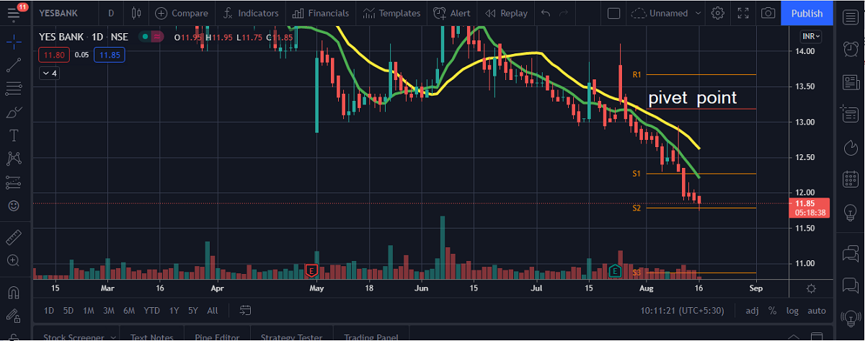

**Page No-95**

# **Pivot Points**

**Pivots Points are price levels chartists can use to determine intraday support and resistance levels. Pivot Points use the previous days Open, High, and Low to calculate a Pivot Point for the current day.**

**Pivot Point support and resistance levels can be used just like traditional support and resistance levels. As with all indicators, it is important to confirm Pivot Point signals with other aspects of technical analysis**

### **Calculation**

**Resistance Level 3 = Previous Day High + 2(Pivot – Previous Day Low)****Page No-96**

**Resistance Level 2 = Pivot + (Resistance Level 1 – Support Level 1)  
Resistance Level 1 = (Pivot x 2) – Previous Day Low  
Pivot = Previous Day (High + Low + Close) / 3  
Support Level 1 = (Pivot x 2) – Previous Day High  
Support Level 2 = Pivot – (Resistance Level 1 – Support Level 1)  
Support Level 3 = Previous Day Low – 2(Previous Day High – Pivot)**

**Page No-97**

**Pivot Point with MA Crossover**

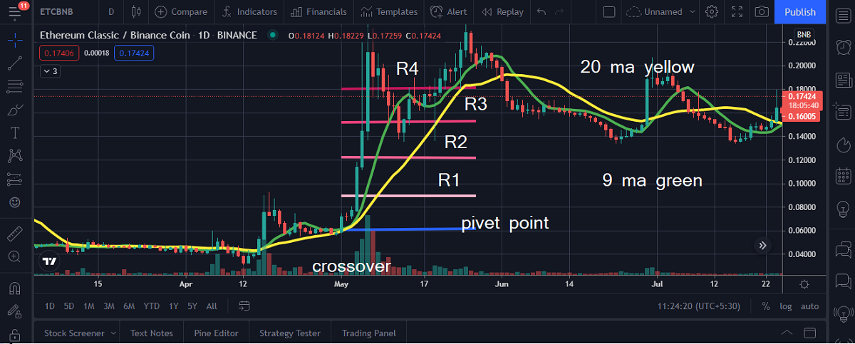

**Page No-98**

**Pivot Point with MA Crossover**

**Long Entry : If make a crossover above pivot point of last candle and current price above of 9 ma and price given breakout of last candle high then you can place a buy order ( make a long position in the market).**

**Long Exit : 9 ma below 20 ma then you can exit from long position.**

**Short Entry : If make a crossover below pivot point of last candle and current price below of 9 ma and price given breakout of last candle low then you can place a sell order ( make a short position in the market).**

**Short Exit : 9 ma above 20 ma then you can exit from short position.**

**Page No-99**

## **Fibonacci Numbers and Lines**

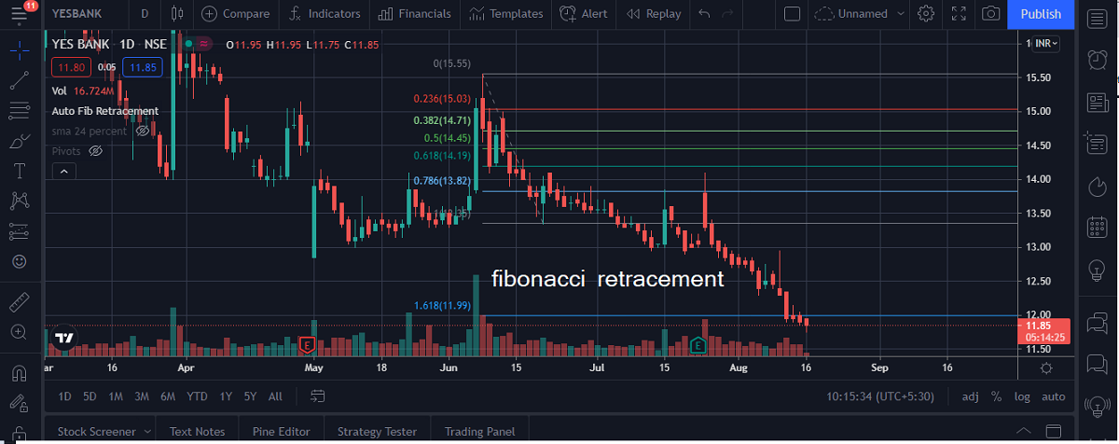

**Page No-100**

## **What are Fibonacci Numbers**

**Fibonacci numbers are used to create technical indicators using a mathematical sequence developed by the Italian mathematician, commonly referred to as "Fibonacci," in the 13th century. The sequence of numbers, starting with zero and one, is created by adding the previous two numbers. For example, the early part of the sequence is 0, 1, 1, 2, 3, 5, 8, 13, 21, 34, 55, 89,144, 233, 377, and so on.**

**This sequence can then be broken down into ratios which some believe provide clues as to where a given financial market will move to.**

**Page No-101**

**The Fibonacci sequence is significant because of the so-called golden ratio of 1.618, or its inverse 0.618. In the Fibonacci sequence, any given number is approximately 1.618 times the preceding number, ignoring the first few numbers. Each number is also 0.618 of the number to the right of it, again ignoring the first few numbers in the sequence. The golden ratio is ubiquitous in nature where it describes everything from the number of veins in a leaf to the magnetic resonance of spins in cobalt niobate crystals**

**Page No-102**

**Fibonacci Line with MA Crossover**

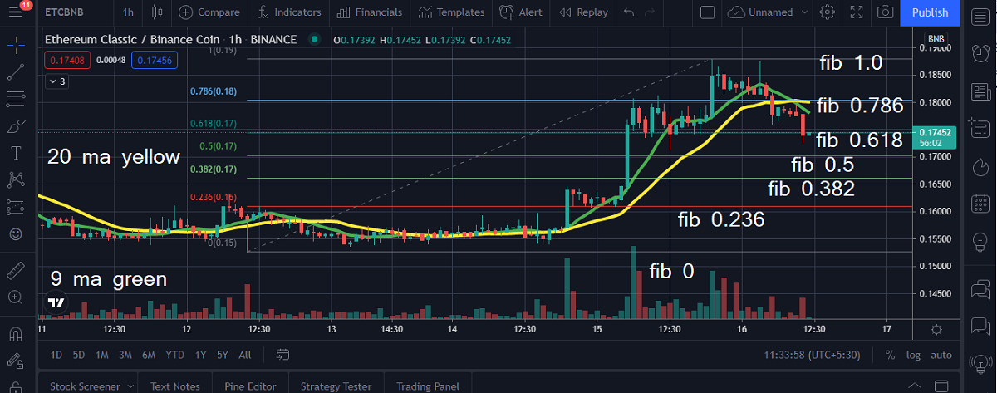

**Page No-103**

**Fibonacci Line with MA Crossover**

**First find highest and lowest point for last 20 candles and plot Fibonacci** **Retracement on your chart.**

**Now wait for 9 ma cross above 20 ma above fibonacci point 23.6(23.6%). If you find crossover above fibonacci 23.6 point then you take long position.**

**Page No-104**

**After open long position 20 ma cross above 9 ma exit from long position.**

**For short position entry and exit opposite of long condition**

**This is power of MA crossover .**

**Page No-105**

**Disclaimer**

**I am not a financial advisory and i am not refer any trading exchange or broker for trading. you can use all given strategy in this book on your risk.we are not resposible for any profit and loss in trading using given strategy. This book purely written for education purpose.**

**Author : Raj Kumar Mantrik**

**Page No-106**

**NOTE**